Name_____________________________________ Block______

**Unit 5B Test Review**

**Do ** problems without a calculator**

1. What is the center of the circle given by the equation ? ( , )
2. **Is the point (6, -5) on a circle with a center of and a radius of 5?
3. Convert the equation  to standard form. 
4. Circle ***P*** has a center at (-3, 5). (5, -1) is a point on circle ***P.***

Is (-3, -5) a point on the circle, in the circle, or outside the circle?

Is (-13, 5) a point on the circle, in the circle, or outside the circle?

Is (-3, 10) a point on the circle, in the circle, or outside the circle?

1. Which is the graph of the circle represented by the equation  ? Circle _____

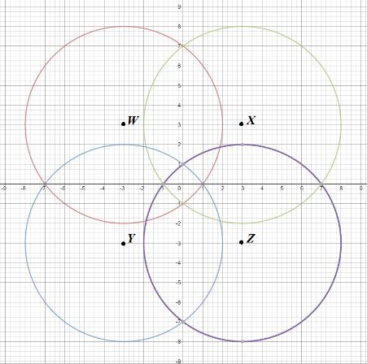

1. Write the equation of a circle with center (1, 5) and diameter 8. 
2. **Write the equation of a circle with a center at (0, -5) and a radius of 4. 
3. **Consider a circle with center (-1, 3) and a point on the circle (x, y). Which of the following represents the radius of the circle?
   1. 
   2. 
   3. 
   4. 
4. **A diameter of a circle has endpoints at (-3, 0) and (-3, 10).

*(Graph to determine the center and radius.)*

What is the equation for this circle in standard form?

What is the equation for this circle in general form?

1. Point  is on a circle with center . What is the radius of the circle? r = __________
2. A student mistakenly wrote the following equation for the graphed circle: 

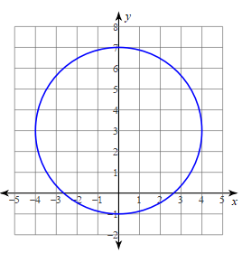 Explain the parts of the equation that are **incorrect**.

________________________________________________

________________________________________________

________________________________________________

________________________________________________

________________________________________________

________________________________________________

________________________________________________

________________________________________________

12. Write the standard form equation for the circle with a center at and a radius of 4.

13. Write the standard form equation for the circle with a center at $(-3, -6)$ and a radius of  .

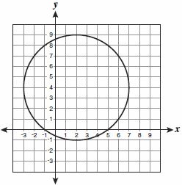14. Write the standard form equation for each graphed circle.

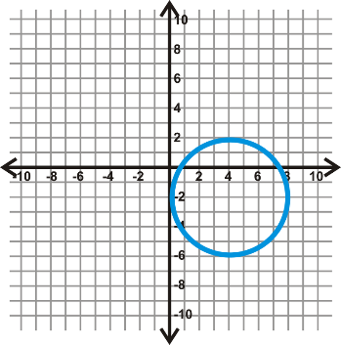

15. Write the standard form equation for the circle with center (-2, 4) and point (0, -4) on the circle.

16. Does the point (13, 16) lie **on, inside, or outside** circle *O* with center (7, 8) and radius 10? Explain.

17. What is the center and radius of the circle given by the equation  ?

18. What is the center and radius of the circle given by the equation  ?

19. What is the center and radius of the circle given by the equation  ?

20. Convert the equation to general form.

21. What is the center and radius of the circle given by the equation ?

22. ** A diameter of a circle has endpoints at (0, -3) and (10, -3). Write the equation of the circle in general form.

23. Write an equation for every circle in the picture below.

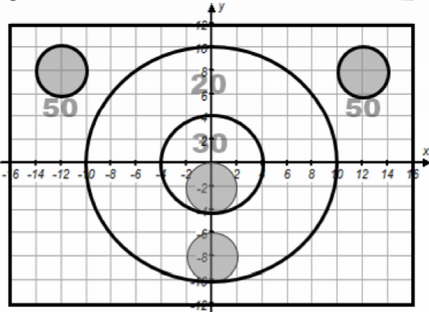

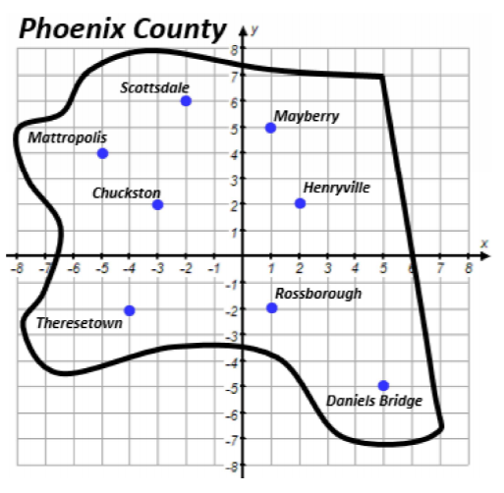24. List all the cities in or on the circle given by the equation: 

25. A circular disk drive has a diameter with endpoints at (3, -4) and (3, 2). Find the center and radius of the disk drive. Write the equation of the circle in standard form.

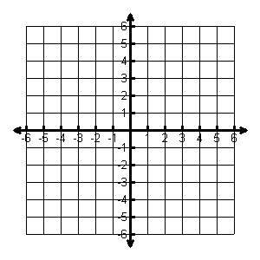

Center: ______________

Radius: ______________

Equation: _______________________

26. Circle C has a center of (-2, 1) and a radius of 6. Does the point (-4, -4) lie on circle C? Show all work to prove.



Statement with reason:

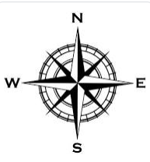27. Jet’s Pizza is at (0, 0) and advertises free delivery within a 5-mile radius. If a customer lives 4 miles west and 4 miles south of Jet’s, do they qualify for free delivery? Show your work.



Statement with reason:

