Name ________________________

**Unit 4B – Test Review**

**Graphing:** Know how to graph one period all 6 trig functions with transformations. Complete the table for the graphed period only.

1. 

|  |  |  |  |  |  |
| --- | --- | --- | --- | --- | --- |
| Domain | Range | Asymptote(s) | Max | Min | Odd/Even |
|  |  |  |  |  |  |

2. 

|  |  |  |  |  |  |
| --- | --- | --- | --- | --- | --- |
| Domain | Range | Asymptote(s) | Max | Min | Odd/Even |
|  |  |  |  |  |  |

1. 

|  |  |  |  |  |  |
| --- | --- | --- | --- | --- | --- |
| Domain | Range | Asymptote(s) | Max | Min | Odd/Even |
|  |  |  |  |  |  |

1. 

|  |  |  |  |  |  |
| --- | --- | --- | --- | --- | --- |
| Domain | Range | Asymptote(s) | Max | Min | Odd/Even |
|  |  |  |  |  |  |

1. 

|  |  |  |  |  |  |
| --- | --- | --- | --- | --- | --- |
| Domain | Range | Asymptote(s) | Max | Min | Odd/Even |
|  |  |  |  |  |  |

1. 

|  |  |  |  |  |  |
| --- | --- | --- | --- | --- | --- |
| Domain | Range | Asymptote(s) | Max | Min | Odd/Even |
|  |  |  |  |  |  |

No calculator

**Graphs of Inverses**

Identify the Graph, State the Domain and Range of Each.

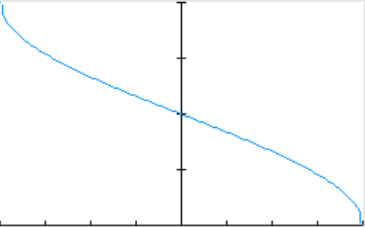

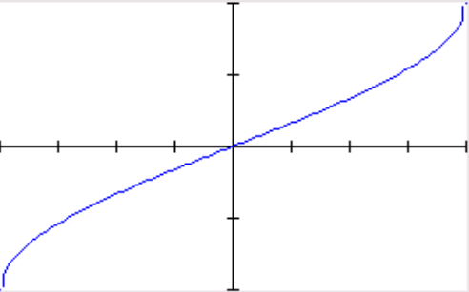

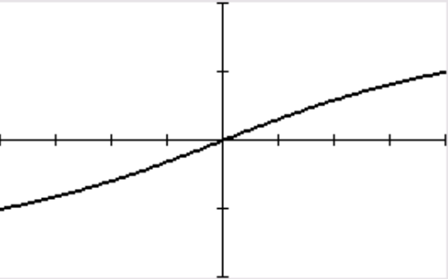

y = __________________ y = __________________ y = __________________

Domain:_____________ Domain:_____________ Domain:_____________

Range:______________ Range:______________ Range:______________

No calculator

**Inverses:** Evaluate the expression. Give exact value in radian (if answer is an angle)

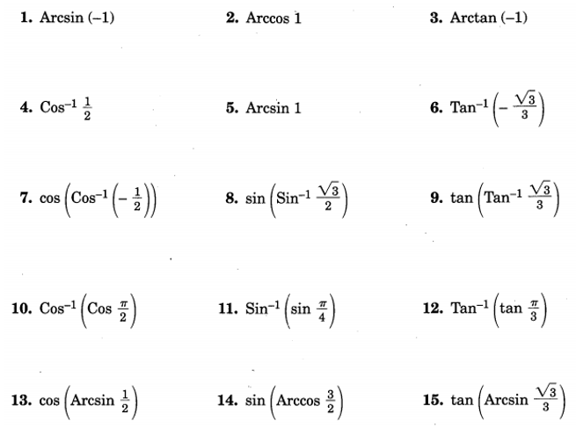

No calculator

**Solve each equation:**

1. 

2. 

3.  (set equal to zero then factor)

4. 

5. 

**Applications:** Draw diagrams to illustrate the problem. Round to the nearest hundredth.

1) A steel cable zip-line is being constructed for competition on a reality television show. One end of the zip-line is attached to a platform on top of a 150 foot pole. The other end of the zip-line is attached to the top of a 5 foot stake. The angle of elevation from the top of the stake to the top of the platform is 23°.

a) How long is the zip-line?

b) How far is the stake from the pole?

2) Standing on top of a 235 foot tall building, you spot your friend on the ground who is 94 feet away from the building.

a) What is the angle of depression you had to look to spot your friend?

b) What is the distance between you and your friend?

**3) Regression:** The highest recorded temp are recorded each month for Salt Lake City.

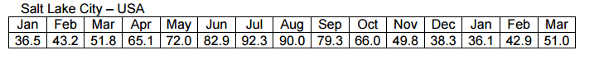Use the given data to find:

1. The regression equation:
2. The average temperature:
3. The period. Based on the period is the equation a good fit?
4. What does the amplitude represent?