**Name_________________________________________**

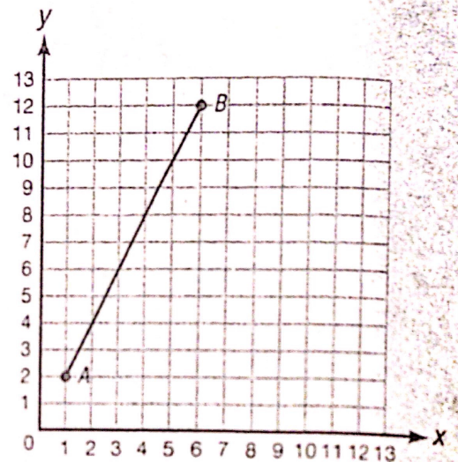**Dividing (Partitioning) a Line Segment Practice**

1. Find the point Q that is $\frac{1}{5}$ the distance from A to B.

Graph point Q. Q = _________

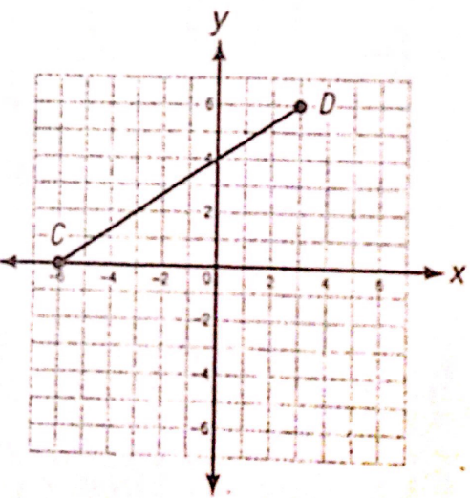

2. Find the point Q that is $\frac{2}{3}$ the distance from C to D.

Graph point Q. Q = _________

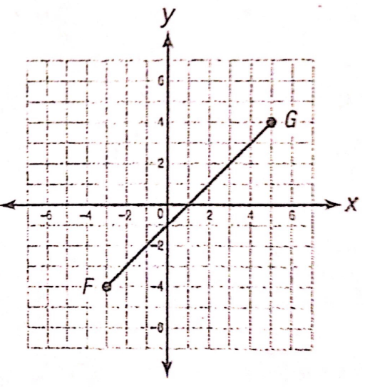

3. Find the point Q that partitions $\overline{FG}$ in a ratio of 1 : 3.

Graph point Q. Q = _________

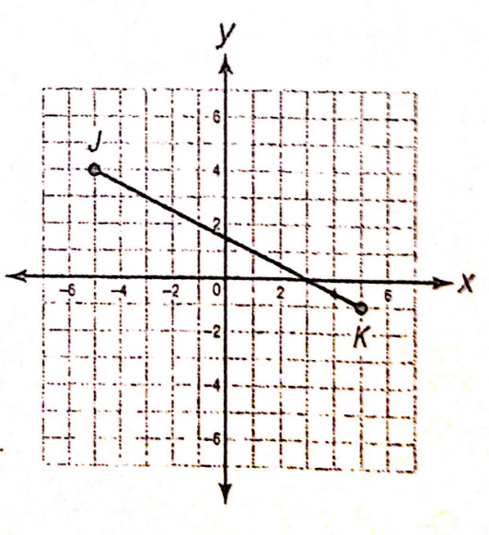

4. Find the point Q that partitions $\overline{JK}$ in a ratio of 3 : 2.

Graph point Q. Q = _________

5. Find the point P that partitions the line segment $\overline{AB}$ in the given ratio.

  Ratio 1 : 5

6. Find the midpoint of the line segment .  

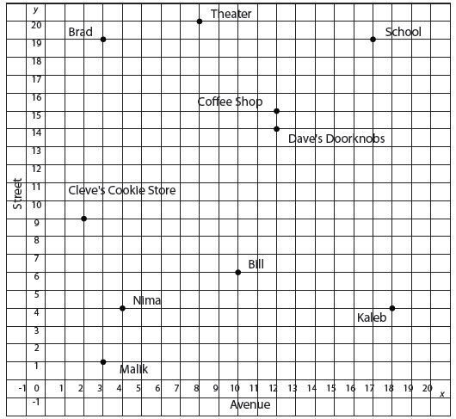**Use the map and the information given to solve each problem that follows.**

7. Luis works at a theater on 8th Avenue and 20th Street. Kaleb lives at the corner of 18th Avenue and 4th Street. What are the coordinates of the location that is **midway** between them?

8. Cleve’s Cookie Store is located at the corner of 2nd Avenue and 9th Street. Dave’s Doorknobs is located at the corner of 12th Avenue and 14th Street. Located 1/5 of the distance from Cleve’s Cookie Store to Dave’s Doorknobs is the post office. What are the coordinates of the post office?

9. What is the **distance** from Bill’s house to Malik’s house? (Each unit represents 0.2 miles)

10. The main entrance to the high school is located at the corner of 17th Ave and 19th St. On his way from school to the bank, Luis stops at the coffees shop located at 12th Ave and 15th St. The coffee shop is the **midpoint** of this trip. What is the location of the bank?