Name: ___________________________________ January 30, 2020

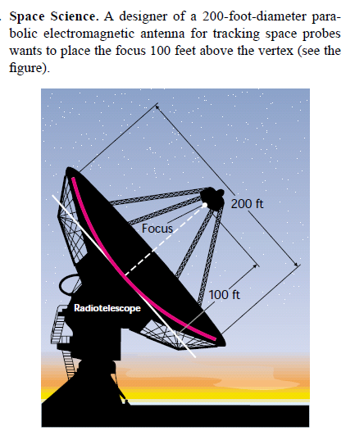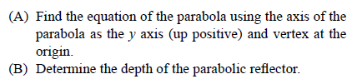**Applications of Parabolas**

1.

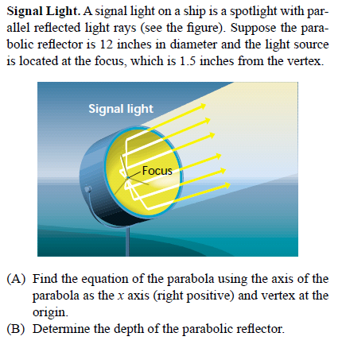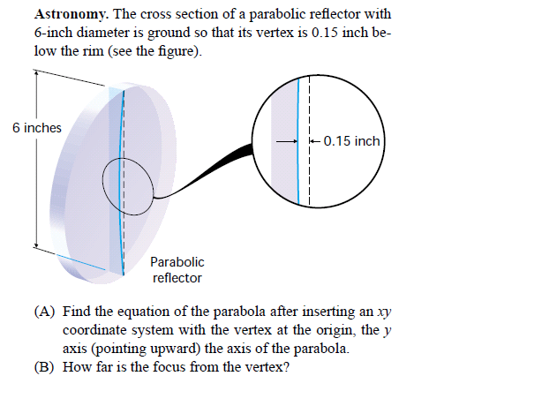

3.

2.

4. Below is a photograph of Bixby Bridge in Big Sur, California. A similar bridge under construction is also shown below. The span of the bridge is to be 1000 ft, and it is to rise 250 ft at the vertex of the parabola.



The roadway is horizontal and will pass 20 ft above the vertex. Vertical columns extend between the parabola and the roadway, spaced every 50 ft horizontally.

a. Using convenient axes, find the particular equation of the parabola.

b. The construction company that builds the bridge must know how long to make each vertical column. Make a table of values showing these lengths.

|  |  |
| --- | --- |
| **Distance from the Vertex** | **Length of the Vertical Column** |
|  |  |
|  |  |
|  |  |
|  |  |
|  |  |
|  |  |
|  |  |
|  |  |
|  |  |
|  |  |
|  |  |

|  |  |
| --- | --- |
| **Distance from the Vertex** | **Length of the Vertical Column** |
|  |  |
|  |  |
|  |  |
|  |  |
|  |  |
|  |  |
|  |  |
|  |  |
|  |  |
|  |  |
|  |  |

c. To order enough steel to make the vertical columns, the construction company must know the total length. Calculate this total length.

**Applications of Ellipses**

1. An arch for a tunnel is in the shape of a semi-ellipse. The distance between vertices is 120 ft, and the height

to the top of the arch is 50 ft. Find the height of the arch 10 ft from the center. Round to the nearest foot.

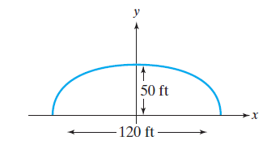

2. A bridge over a gorge is supported by an arch in the shape of a semi-ellipse. The length of the bridge is 400 ft, and the height is 100 ft. Find the height of the arch 50 ft from the center. Round to the nearest foot.

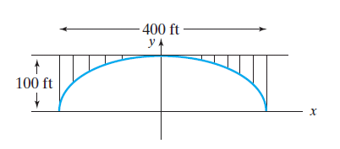

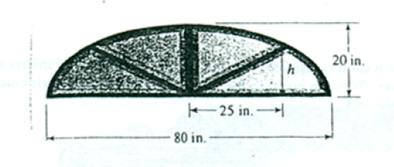3. A window shaped like a semi-ellipse is 20 inches tall at its highest point and 80 inches wide at the bottom. Find the height of the window 25 inches from the center of the base.

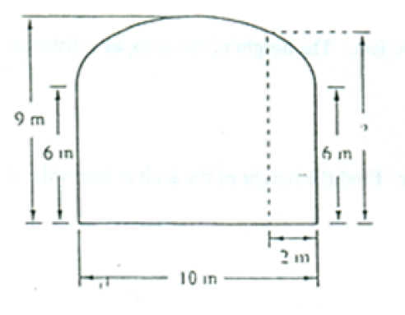4. The ceiling in a hallway 10 m wide is in the shape of a semi-ellipse and is 9 m high in the center and 6 m high at the sidewalls. Fin the height of the ceiling 2 meters from either wall.

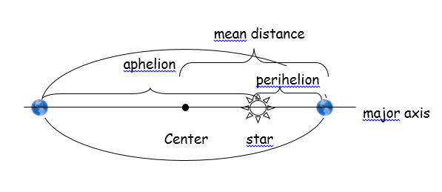(5-6) For the next problems, use the following facts about orbits: The orbit of a planet about a star is an ellipse, with the star at one focus. The aphelion of a planet is its greatest distance from the star, and the perihelion is its shortest distance. The mean distance of a planet from the star is the length of half of the major axis of the elliptical orbit. See the illustration:

5. **Mars.** The mean distance of Mars from the Sun is 142 million miles. If the perihelion of Mars is 128.5 million miles, what is the aphelion? Write an equation for the orbit of Mars about the Sun.

6. **Jupiter.** The aphelion of Jupiter is 507 million miles. If the distance from the Sun to the center of its elliptical orbit is 23.2 million miles, what is the perihelion? What is the mean distance? Write an equation for the orbit of Jupiter around the Sun.

(7-8) For the next problems, read the following information about an elliptical dome: An interesting property of an elliptical dome is that a sound or light source at one focus will reflect off the dome and pass through the other focus. One of the chambers in the Capitol Building in Washington, D.C., has such a dome, and is referred to as a whispering room because a whispered sound at one focus can be easily heard at the other

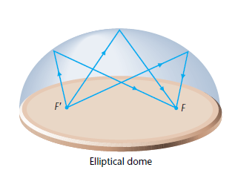focus.

7. **Whispering Gallery** Statuary Hall is an elliptical room in the United States Capitol in Washington D.C. This room, sometimes called the Whispering Gallery is 46 ft. wide and 96 ft. long. John Quincy Adams is said to have used the focusing properties of the room to overhear conversations.

* 1. Find an equation that models the shape of the room.
  2. What is the area of the floor of the room? (The area of an ellipse is .)
  3. Where should the people stand to hear each other (that is – find the foci)

8. A hall 100 feet in length is to be designed as a whispering gallery. If foci are located 25 feet from the center, how high will the ceiling be at the center?

9. The moon orbits Earth in an elliptical path with the center of the Earth at one focus. The major axis of the orbit is 774,000 kilometers, and the minor axis is 773,000 kilometers. Using (0, 0) as the center of the ellipse, write the standard equation for the orbit of the Moon around Earth. How far from the center of Earth is the Moon at its closest point? How far from the center of Earth is the Moon at its farthest point?

10. A fairly recent application in medicine is the use of elliptical reflectors and ultrasound to break up kidney stones. A device called a lithotripter is used to generate intense sound waves that break up the stone from outside the body, thus avoiding surgery. To be certain that the waves do not damage other parts of the body, the reflecting property of the ellipse is used to design and correctly position the lithotripter.

A lithotripter is formed by rotating the portion of an ellipse below the minor axis around the major axis (see the figure below). The lithotripter is 20 centimeters wide and 16 centimeters deep. If the ultrasound source is positioned at one focus of the ellipse and the kidney stone at the other, then all the sound waves will pass through the kidney stone. How far from the kidney stone should the point *V* on the base of the lithotripter be positioned to focus the sound waves on the kidney stone? Round the answer to one decimal place. 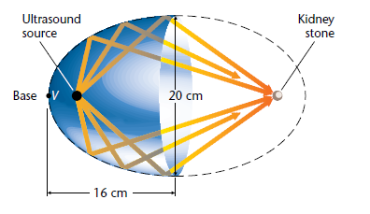

**Applications of Hyperbolas**

*Solve the problems*

1. A hyperbolic mirror can be used to take panoramic photographs. A camera is pointed toward the vertex of the mirror and is position so that the lens is at one focus of the mirror. An equation for the cross section of the mirror is  where *x* and *y* are measured in inches. How far from the mirror is the lens?

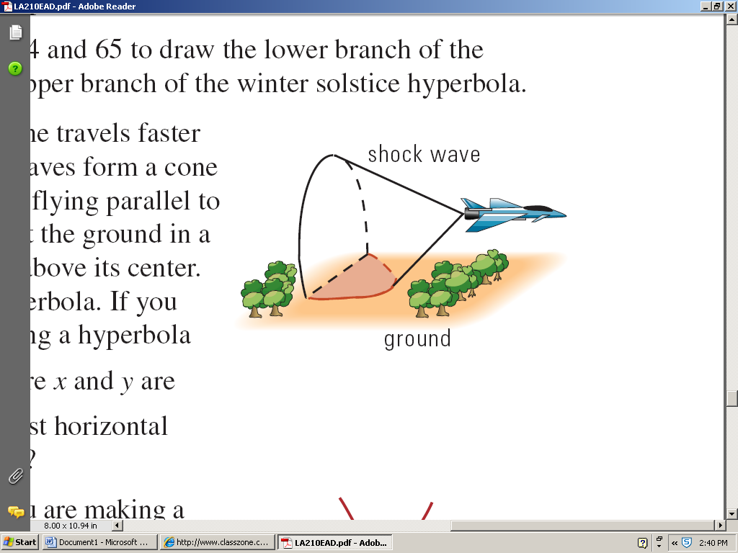2. When an airplane travels faster than the speed of sound, the sound waves form a cone behind the airplane. If the airplane is flying parallel to the ground, the sound waves intersect the ground in a hyperbola with the airplane directly above its center. A sonic boom is heard along the hyperbola. If you hear a sonic boom that is audible along a hyperbola with the equation where *x* and *y* are measuring in miles, what is the shortest horizontal distance you could be from the plane? If the plane is flying at an altitude of 215 mi above the ground, what is the shortest “straight” distance between you and the plane?

3.Comets with a high velocity cannot be captured by the sun’s gravity and are slung around the sun in a hyperbolic path with the sun at one focus. If the path illustrated by the graph shown is modeled by the equation , how close did the comet get to the sun. Assume units are in millions of miles and round to the nearest million.



(0, 0)

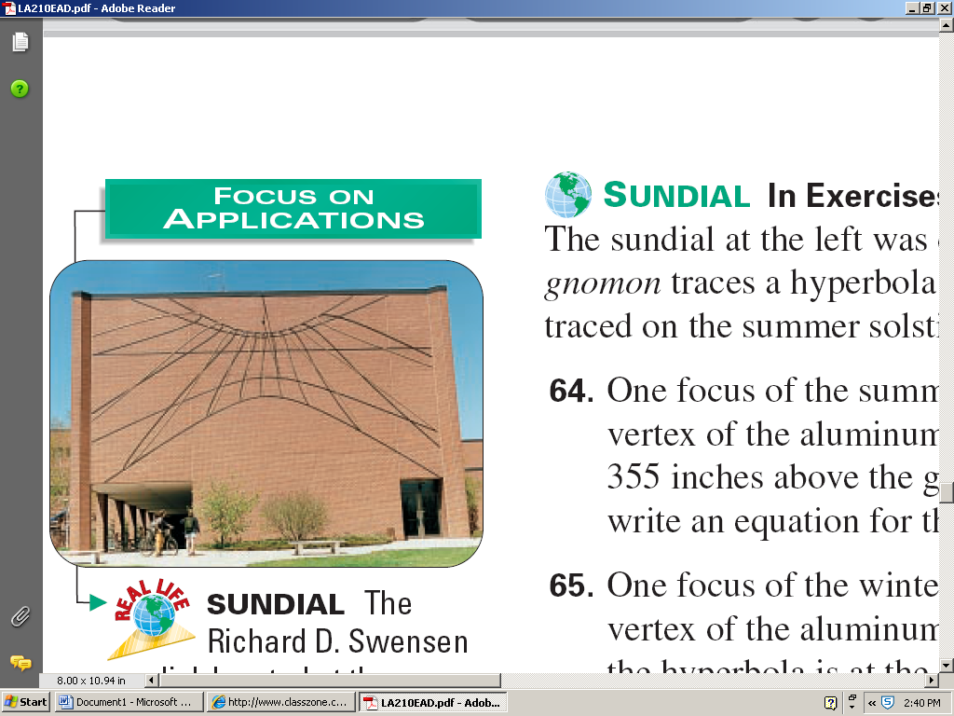

(4-5) The sundial in the photograph was designed by Professor John Shepherd. The shadow of the *gnomon* traces a hyperbola throughout the day. Aluminum rods form the hyperbolas traced on the summer solstice, June 21, and the winter solstice, December 21.

4. One focus of the summer solstice hyperbola is 207 inches above the ground. The vertex of the aluminum branch is 266 inches above the ground. If the *x*-axis is 355 inches above the ground and the center of the hyperbola is at the origin, write an equation for the summer solstice hyperbola.

5. One focus of the winter solstice hyperbola is 419 inches above the ground. The vertex of the aluminum branch is 387 inches above the ground and the center of the hyperbola is at the origin. If the *x*-axis is 355 inches above the ground, write an equation for the winter solstice hyperbola.