Geometry Name: _______________________
Transformations Review So Far…
 | Translating a point by (x – 2, y + 5) means: | Translating a point by (x – 3, y) means: | 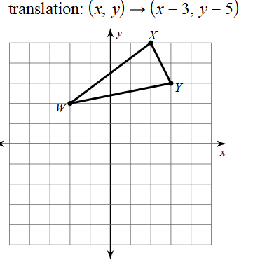
 | Write the coordinates of the image:  Reflect (5, -8) across the x-axis  Reflect (5, -8) across the y-axis | Write the coordinates of the image:  Reflect (5, -8) across the line y = -x | 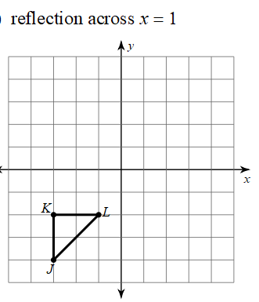
 | Write the coordinates of the image:  Rotate (-5, 4) 90° clockwise about the origin.  Rotate (7, 10) 270° clockwise about the origin. | Write the coordinates of the image:  Rotate (-5, 4) 90° counterclockwise about the origin.  Rotate (7, 10) 270° counterclockwise about the origin. | 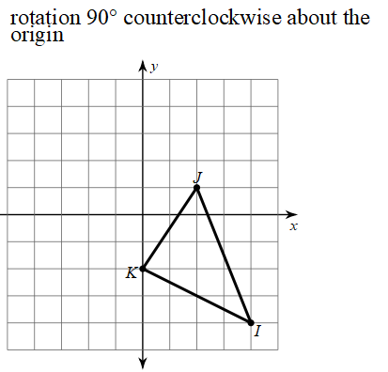
 | Write the coordinates of the image:  Rotate (-7, 0) 180° about the origin. | Write the coordinates of the image:  Rotate (-7, 9) 180° about the origin. | 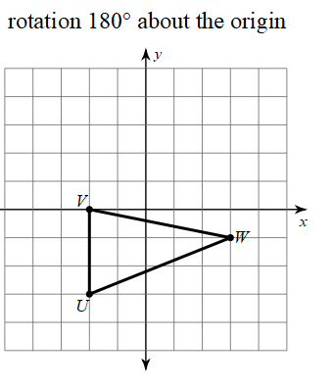
 | Define Congruent: | Define  Translation:  Rotation:  Reflection: | Define dilation:  Why is a dilation NOT an isometry?
 | 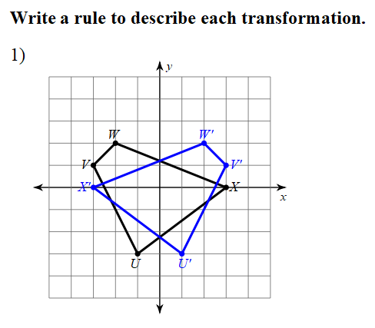 | 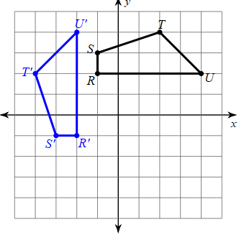 | 