Name____________________________ Block _____
Applications: Arc Length and Area of Sectors
- Do 8 problems.
  - You must choose 4 from #1-10.
  - You must choose 4 from #11-19.
- Choosing problems with ** will give you extra points on this assignment.
- Take your best problem and make a small poster of it using a sheet of white copy paper.
  - Top Left Box: Write out the problem.
  - Top Right Box: Show all your work.
  - Big Box: Draw the picture of the scenario.
    - Label any given lengths, area, and/or angles.
    - Write the answer in a complete sentence.
    - Color it
- Due Tomorrow 1.23.2020
- Quiz Grade

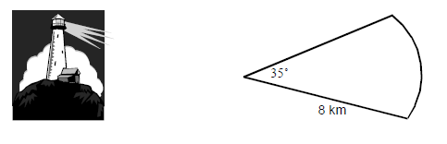
1. The beam from a lighthouse reaches a distance of 8 kilometers and spreads to an angle of 35°.Calculate the area covered by the beam from the lighthouse.

2. The curved part on an anchor is in the shape of an arc of a circle which has radius 1.2 meters. Calculate the length of this arc.

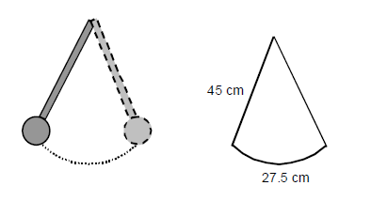
3. A pendulum is 45 centimeters long. When the pendulum swings it travels along the arc of a circle and covers a distance of 27.5 centimeters. Calculate the size of the angle through which the pendulum travels.

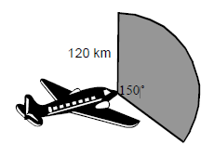
4. The radar beam sent out by an airplane reaches a distance of 120 kilometers and covers an angle of 150°. Calculate the area covered by the beam.

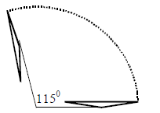
5. A windshield wiper is 45 centimeters long. In one sweep it turns through an angle of 115°. Calculate the distance the tip of the wiper blade covers in one sweep.

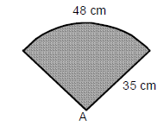
6. A fan is in the shape of an arc of a circle with radius 35 centimeters. Calculate the size of the angle at A.

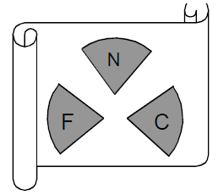
**7. The diagram below shows the emblem for a sports club. The emblem consists of 3 identical sectors of a circle, each of radius 16 millimeters. The sectors have a combined area of 335 square millimeters. Calculate the size of angle at the center of each sector.

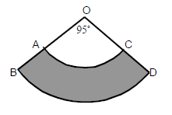
**8. In the diagram below AC and BD are arcs of circles with centers at O. The radius, OA, is 10 centimeters and the radius, OB, is 16 centimeters. Find the shaded area.

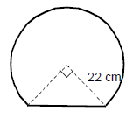
**9. The diagram below shows a mirror. The mirror is in the shape of the sector of a circle with a straight base. The radius of the sector is 22 centimeters. Calculate the distance round the outside of the mirror.

**10. The circular shelves in diagram are each 28 inches in diameter. The “cut-out” portion of each shelf is 80°. Approximately how much shelf paper is needed to cover both shelves?

11. Different animals have different fields of view. Humans can generally see a 180° arc in front of them. Horses can see a 215° arc. A horse and rider are in heavy fog, so they can see for only 25 yards in any direction. Find the area of the horse’s field of view.

12. A Ferris wheel has a radius of 30 feet. How far does a car on the Ferris wheel travel in a rotation of ${60}^{o}$?

13. The speedometer needle in Ignacio’s car is 2 inches long. The needle sweeps out a 130° sector during acceleration from 0 to 60 mi/h. Find the area of this sector.

14. A windshield wiper blade of a car is 24 inches long. In one sweep, the wiper blade covers 553 square inches of area. How many degrees does the wiper blade turn through in one sweep?

15. A grandfather clock has a pendulum 22 cm long. If it swings through an angle of ${32}^{o}$, how far does the bottom of the pendulum travel in one swing?

16. A man is running around a circular track with a diameter of 75 yards. How far does the man run in ${270}^{o}?$

17. The wheel of a unicycle has a diameter of 5 ft. How far does the bike move when you turn the pedals through an angle of ${90}^{o}$?

18. A clock’s minute hand is 6 inches long and makes a central angle of ${150}^{o}$ from 12:00 am to 12:25. How far does the tip of the minute hand travel during that time?

19. A dog is leashed to the corner of a rectangular house. If the dog’s leash is 20 feet long, how much area does the dog have in which to run?

