Name________________________________________
Distance Formula Practice
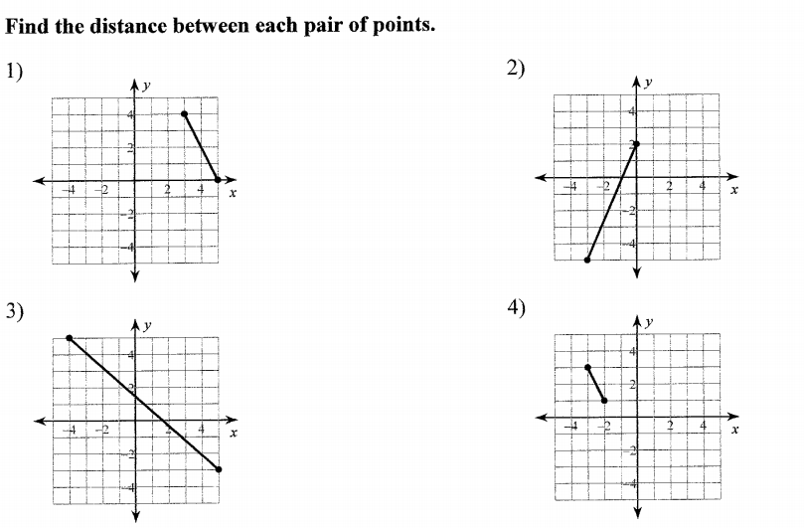
5. Tyler and Arsha have mapped out locations for a game of manhunt. Tyler’s position is represented by the point (-2, 1). Arsha’s position is represented by the point (-7, 9). Each unit is equivalent to 100 feet. What is the approximate distance between Tyler and Arsha?

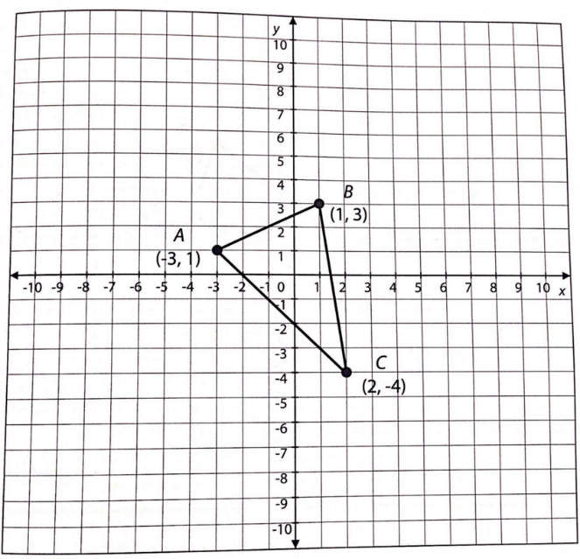
6. Find the perimeter of the triangle.

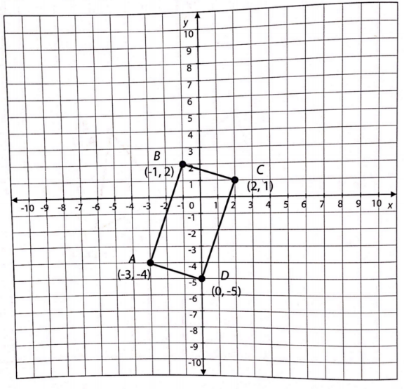
7. Find the area of the rectangle.

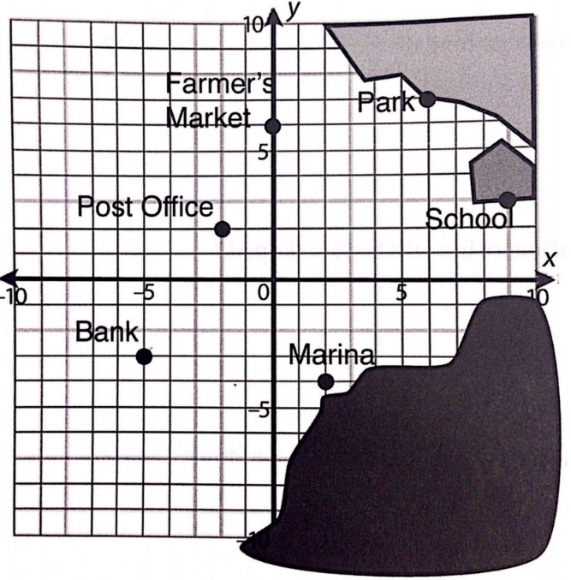
8. Each unit on the map is equivalent to 1,000 feet. Round your answers to the nearest foot. Find the distance from the:
A. Post office to the bank

B. Marina to the school

C. Park to the farmer’s market

D. Farmer’s market to the bank

E. Bank to the park

F. Marina to the farmer’s market.

9. The local recreation department has created a map of is newest baseball field. The department is planning to install a rectangular fence around the field. The corners of the field are represented on the map by the points A(-5, -10), B(10, -5), C(4, 23), D(-11, 18). How many feet of fencing are needed for the baseball field? What is the area of the fenced-in field? Each unit on the map represents 10 feet.

