Unit 3 Intro to Trig: Test Review
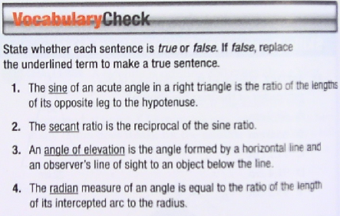
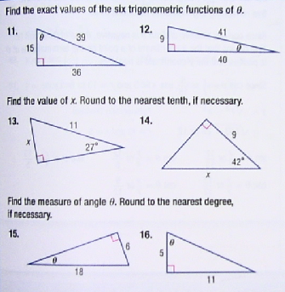
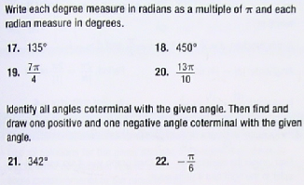
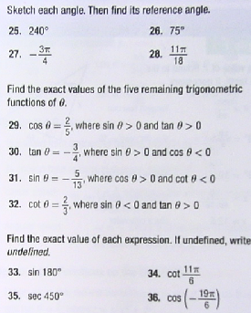

Angles of Elevation & Depression
Draw a picture, write a trig ratio equation, and then solve each problem. Round answers to the nearest tenth.

________ An escalator from the ground floor to the second floor of a department store is 110 ft long and rises 32 ft. vertically. What is the escalator’s angle of elevation?  110  32 | ________ From the top of a lighthouse 210 feet high, the angle of depression of a boat is 27°. Find the distance from the boat to the foot of the lighthouse. The lighthouse was built at sea level.
________ A person at one end of a 230-foot bridge spots the river’s edge directly below the opposite end of the bridge and finds the angle of depression to be 57°. How far below the bridge is the river? | ________ An airplane rises vertically 1000 feet over a horizontal distance of 5280 feet. What is the angle of elevation of the airplane’s path?
________ A radio tower 200 ft. high casts a shadow 75 ft. long. What is the angle of elevation of the sun? | .________A person in an apartment building sights the top and bottom of an office building 500 ft. away. The angle of elevation for the top of the office building is 23° and the angle of depression for the base of the building is 50°. How tall is the office building?
________ A rescue team 1000 ft. away from the base of a vertical cliff measures the angle of elevation to the top of the cliff to be 70°. A climber is stranded on a ledge. The angle of elevation from the rescue team to the ledge is 55°. How far is the stranded climber from the top of the cliff? | ________ A ladder on a fire truck has its base 8 ft. above the ground. The maximum length of the ladder is 100 ft. If the ladder’s greatest angle of elevation possible is 70°, what is the highest above the ground that it can reach?

