Name________________________________

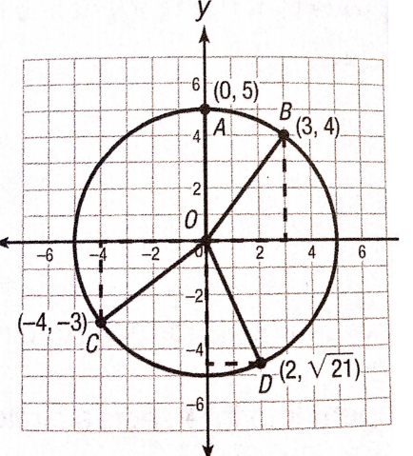**Using Coordinates to Prove Theorems about Circles PRACTICE**

1. **Use circle O to prove that all radii of a circle have the same length.**

The length of radius OA is ______.(Just count)

Find the lengths of other radii. (Use the distance formula!)

OB = ______________________________________________

OC = ______________________________________________

OD = ______________________________________________

2. **Prove or disprove that the point (13, 16) lies on circle O with center (7, 8) and diameter 20.**

3. **The line  is tangent to the circle  at the point (4, 4). Prove the tangent line is perpendicular to the radius at the point of tangency.**

*Slope of the tangent line = ______*

*Slope of the radius = ________*

Answer: The tangent line ***is/is not*** perpendicular to the radius at the point of tangency because the slopes of the tangent line and of the radius ***are/are not*** opposite reciprocals.

4. **The line  is tangent to the circle  at the point (-3, 6). Prove the tangent line is perpendicular to the radius at the point of tangency.**

*Slope of the tangent line = ______*

*Slope of the radius = ________*

Answer: The tangent line ***is/is not*** perpendicular to the radius at the point of tangency because the slopes of the tangent line and of the radius ***are/are not*** opposite reciprocals.

5. **Show that the equation of the circle with endpoints on the diameter (4, -1) and (-6, 7) is **

Center = ________ (Midpoint formula) Radius = ________ (Distance formula)

Equation of circle: ______________________________

Convert the above equation to general form.

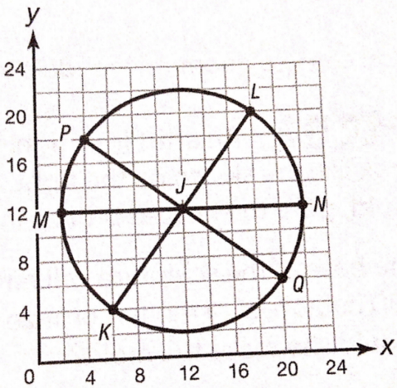

6. **Prove that the diameter of circle J is twice the length of its radius**.

MN = _______ (Just count)

MJ = ________ (Just count)

KL = ________________________________(distance formula)

KJ = ________________________________(distance formula)

So, each diameter is ________ the length of each radius.

7. **Prove or disprove that the point (-9, 3) lies on circle O with center (-5, 3) and contains the point (-1, 4).**

***For 8-9: Graph using the attached graph paper.***

8. **Write the equation of the circle with center (10, -14) and tangent to the line x = 15.**

9. **Write the equation of the circle whose center lies in the 1st quadrant and is tangent to the lines x = 8, y = 3, and x = 14.**



