Name________________________________________________________________ Block ______________

**Parallel and Perpendicular Lines**

1. Write the equation of the line **parallel** to the graphed line that passes through the point (-12, 5). 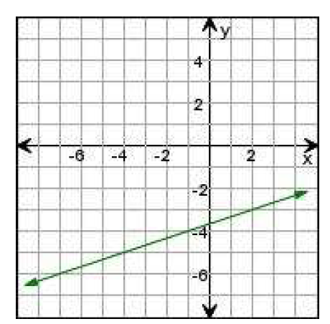

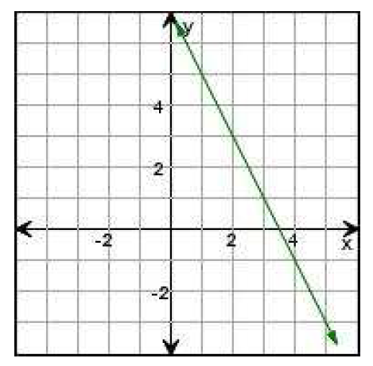2. Write the equation of the line **perpendicular** to the graphed line that passes through the point (10, -2).

3. Write an equation for the line that is:

a) **parallel** to  and passes through the point (12, -6)

b) **perpendicular** to  and passes through the point (12, -6)

For each:

A) Write the equation in slope-intercept form. 

B) Write an equation for the line that is **parallel** to the given line and passes through the given point.

C) Write an equation for the line that is **perpendicular** to the given line and passes through the given point.

4. (6, 4); 

5. (-5, 5); 

6. (-1, -4); 