Solving Systems of Equations Using Inverse Matrices Practice

Directions: Write each system as a matrix equation AX = B and solve using inverse Matrices. Show steps. You can use a Calculator for problems 5 & 6 to find inverses and multiply. (Remember: prior to writing the matrix equation align like variables on left side, constants on the right.)
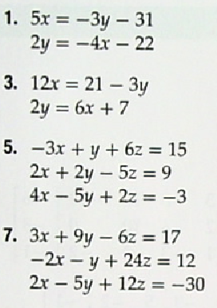

This is not one of our standards….but if you get bored, teach yourself how to solve by Gauss-Jordan elimination
Page 369 Example 5. (From 2nd Period’s Pre-Calc Book)
