Name______________________________________________- Block _________
Triangle Similarity HOMEWORK
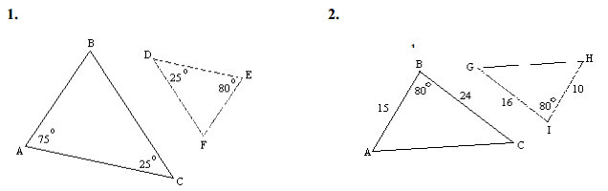
Prove that each pair of triangles are similar using either AA, SAS, or SSS

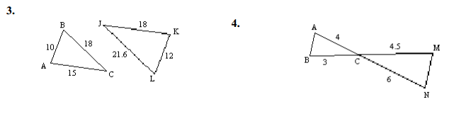

For each pair of triangles, state whether the triangles are similar by SSS, AA, or SAS. If the triangles are not similar, state not similar.
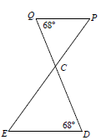
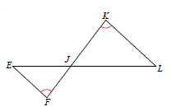
1. 2.

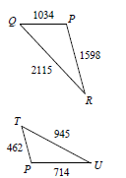
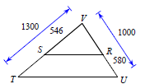
3. 4.

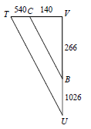
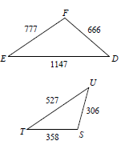
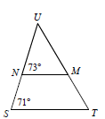
5. 6. 7.

