Name_____________________________________________________________

**Parallel and Perpendicular Lines HOMEWORK**

A. Write an equation that is **parallel** to the given line through the given point.

B. Verify by graphing **both lines.**

1.  2. 

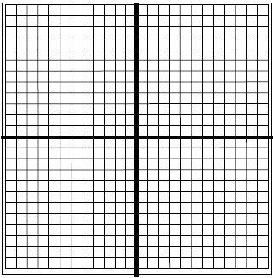

A. Write an equation that is **perpendicalar** to the given line through the given point.

B. Verify by graphing **both lines.**

3.  4. 

