Name_____________________________________________________ Block _____________

**Tangents to Circles Homework**

For Exercises 1–5, match the letter of the part of the figure to the names. Use each letter once.

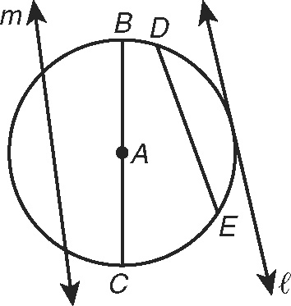 1. chord ________ A. 

2. tangent ________ B. 

3. radius ________ C. m

4. secant ________ D. 

5. diameter ________ E. 

**6. Determine if line AB is tangent to the circle. Show your work.**

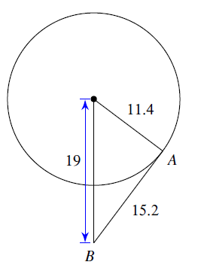

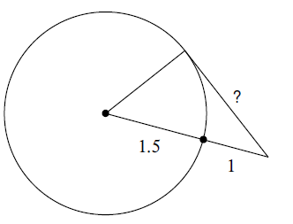**7. Find the segment length indicated. Assume that lines which appear to be tangent are tangent.**

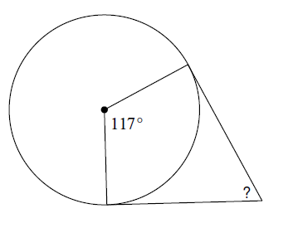

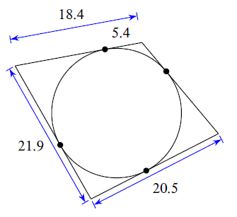**8. Find the perimeter of each polygon. Assume that lines which appear to be tangent are tangent.**

**9. Find the angle measure indicated** **. Assume that lines which appear to be tangent are tangent.**

10.  and  are tangent to ⊙J. Find **GH**.

