Reflections HOMEWORK Name________________________________
State and draw the line of reflection on the graph.
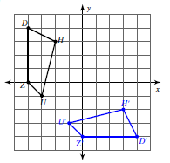
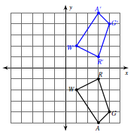
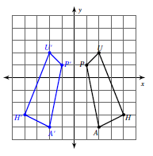
1. Line of reflection: 2. L ine of reflection: 3. Line of reflection:

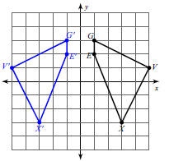
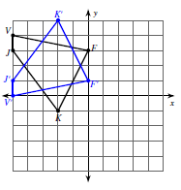
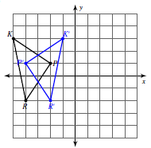
4. Line of reflection: 5. L ine of reflection: 6. Line of reflection:

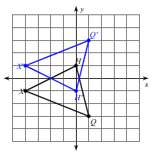
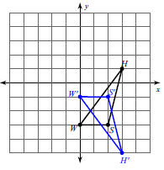
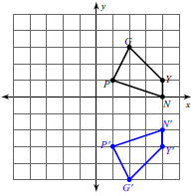
7. Line of reflection: 8. L ine of reflection: 9 . Line of reflection:

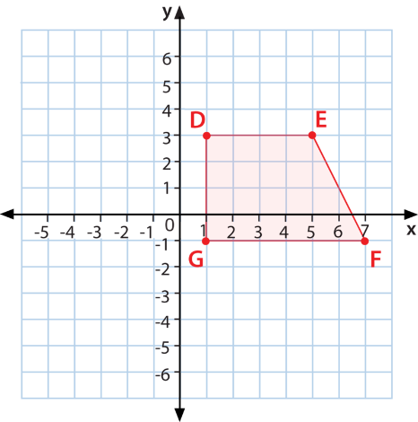
10. Trapezoid DEFG below is reflected so that D’= (-5, 3), what is the line of reflection?

