**Name__________________________________________**

**Unit 4C: Circles and Volume TEST REVIEW**

**Volume**

1. What is the volume of a cylinder with a radius of 4 in. and a height of 

1. What is the radius of a sphere with volume?
2. The cone shown has a base with a radius of AB. The length of radius AB is 8 cm and the length of slant height BC is 10 cm.
   1. 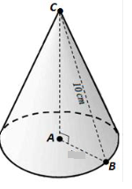What is the height of the cone? (Pythagorean Theorem)
   2. Find the volume of the cone.

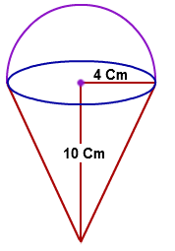

1. Which is the volume of the composite figure of a hemisphere and a cone below?
2. A sphere is inscribed in a cube with side lengths of 12 inches. What is the volume of the sphere?

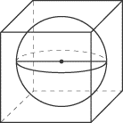

1. What does Cavalieri’s principle say about the right cylinder and the oblique cylinder below?

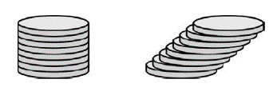

_____________________________________________________________________________

1. 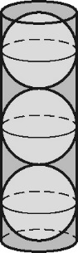The figure below shows 3 tennis balls stacked tightly in a cylindrical can. The circumference of one tennis ball is 10 inches.
   1. Write an expression in terms of for the radius of the can.
   2. Write an expression in terms of for the height of the can.
   3. Write an expression in terms of for the volume of the can.
2. 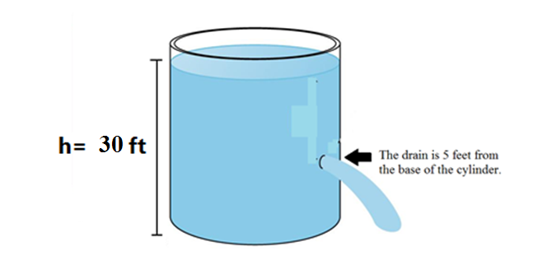A **cylindrical** tank has a **radius** of **8** **feet**. The **height** of the water in the tank is **30** **feet**. When the drain plug is pulled, the water will **drain** at a **rate** of **20** **gallons** **per** **minute**. The water will stop draining when the water level reaches the height of the drain.
   1. How many cubic feet of water will be drained? (Round to the nearest cubic foot.)
   2. How many gallons is that?
   3. To the nearest minute, how long will it take for the water to stop draining?
   4. How many hours is that?
3. A cylinder has a volume of  cubic feet and a radius of 6 feet.

What is the cylinder’s height?_________

**Arc Length and Area of a Sector**

1. 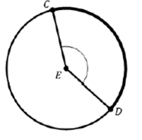Circle with center E is shown. The *m*∠CEDand the length of CE is 6 cm. What is the length of $\hat{CD}$?
2. 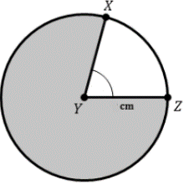Circle with center Y is shown. The *m*∠XYZand the length of YZ is 3 cm. What is the area of the **shaded** part of the circle?
3. 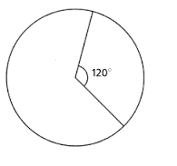The circle below has a radius of 8 cm. Rounded to the nearest whole number, what is the area of the sector below whose central angle is  ?
4. 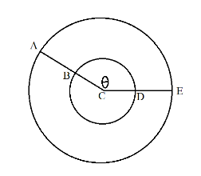The image below shows two circles, both with center *C.* . . The length of minor arc . What is the length of minor arc *AE* ?
5. 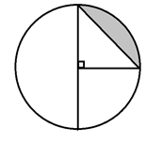The radius of the circle below is 2 units. Write an expression that represents the area of the shaded segment in the circle below
6. A toy car driving **clockwise** around the circular track completes one full lap around every 12 seconds. How long does it take the toy car to travel from point A to point B?

