Name____________________________________________________________________ Block___

**Identifying Sequences of Transformations PRACTICE**

***Name the sequence of transformations that maps the pre-image to its image.***

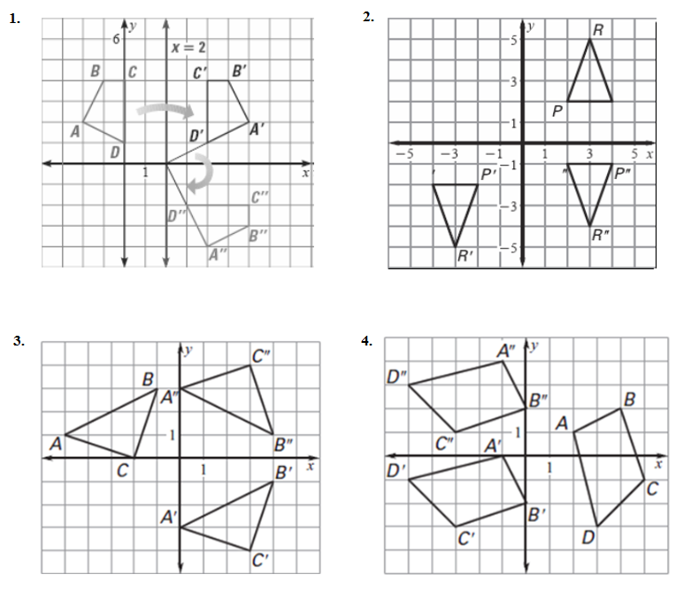

List a sequence of transformations that will carry the shaded pre-image to its unshaded image.

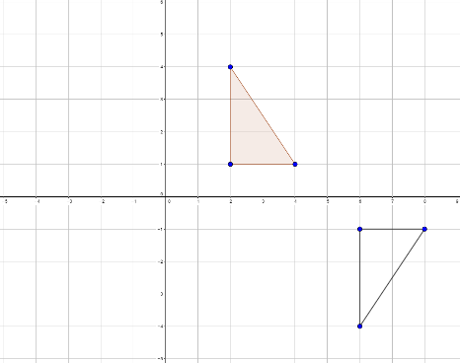5.

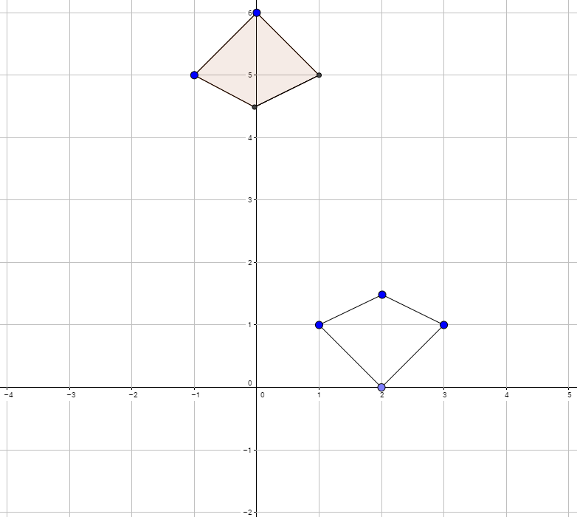

6.

7.

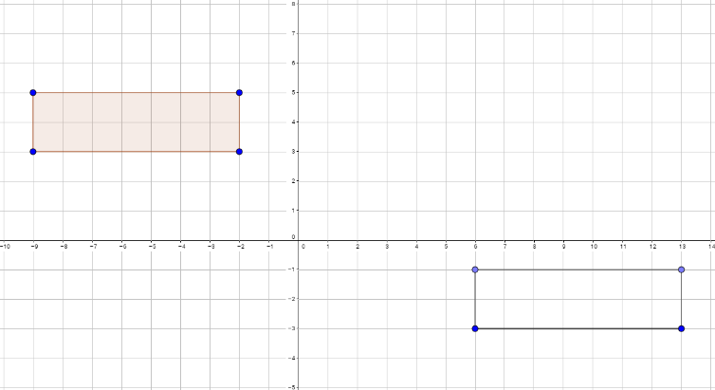

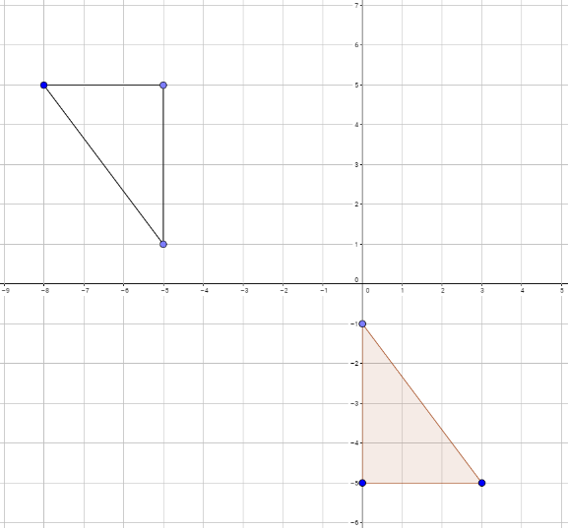8.

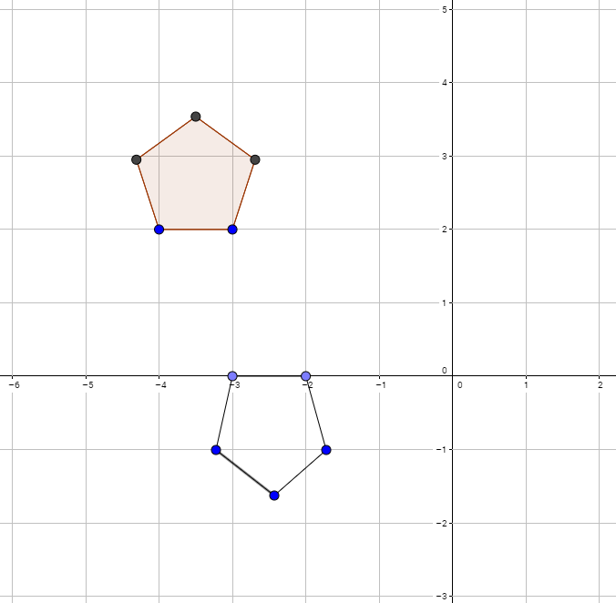

9.

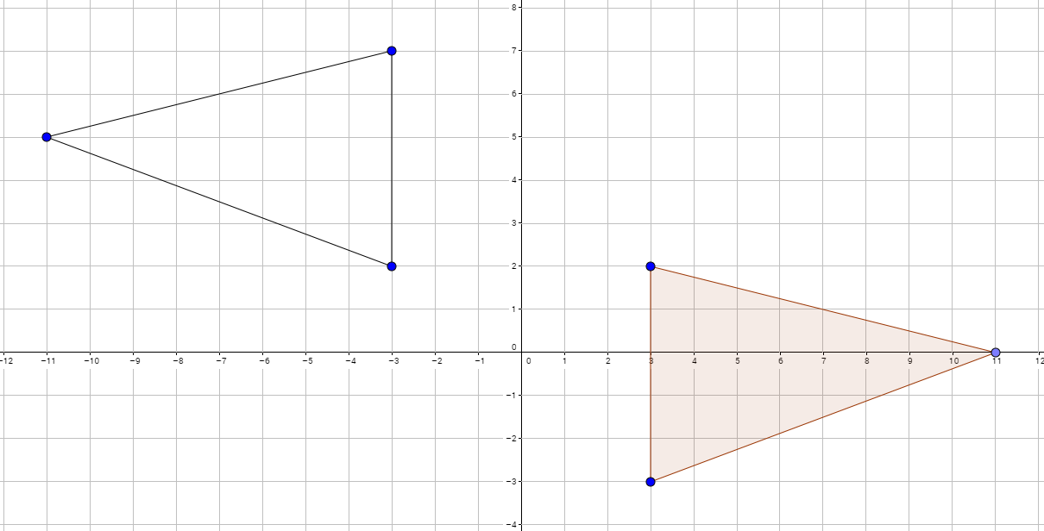10.

