Name________________________________Date________
Given that A and B are complementary angles:
Label each triangle side lengths using the ratios, and A and B if not already labeled

1. sin A = 3/5  B  A  cos B= | 2. cos A = 5/6  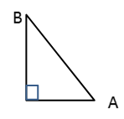  sin B= | 3. sin A = ¾  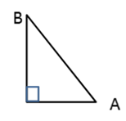  cos B=
4. sin B = 3/8  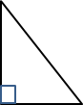  cos A= | 5. sin A = 20/37  cos B= | 6. sin B = 25/38, what other trig ratio = 25/38?  ________
7. If cos A = 17/35, what other trig ratio = 17/35?  ________ | 8. If sin A = 38/91, what other trig ratio = 38/91?  _________ | 9. If cos B= 16/25, what other trig ratio = 16/25?  _______
10. If sin A = 8/17, what other trig ratio = 8/17?  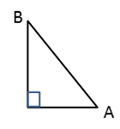  ________  C  $\overline{AC}=$________  cos A =______ | 11. If cos B = 3/5, what other trig ratio = 3/5?  ________  $\overline{AC}=$________  C  sin B =______ | 12. If sin B = 5/13, what other trig ratio = 5/13?  ________  C  $\overline{AC}=$________  cos A =______
13. If sin A = 30/34, what is cos B?
In your own words, explain why.

Find the missing angle.
14.  $$sin20°=cos⁡________°$$ | 15.  $$sin50°=cos⁡________°$$ | 16.  $cos32°=sin⁡_________°$
17.  $sin 47.2°=cos⁡________°$ | 18.  $cos12.6°=sin⁡_________°$ | 19.  $sin47°=cos⁡_________°$
20.  $cos51.2°=sin⁡________°$ | 21.  $cos38°=sin⁡_________°$ | 22.  $sin 82.5°=cos⁡________°$

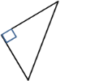
Find all trig ratios for each right triangle.
A
B
8
6
10
23.  13  5  12  sin A= ______ sin B = _____  cos A = _____ cos B =_____  tan A =______ tan B = _____ | 24.  sin A= ______ sin B = _____  cos A = _____ cos B =_____  tan A =______ tan B = _____
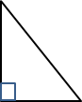  25.  β  θ  5  3  4  $\sin{θ}=$______ $\sin{β}=$ _____  $\cos{θ}=$ _____ $\cos{β}=$_____  $\tan{θ}=$ ______ $\tan{β}=$ _____ | 26.  sin A= $\frac{21}{35}$ sin B = _____  A  B  cos A = _____ cos B =_____  tan A = _____ tan B = $\frac{28}{21}$
