**Name_______________________________**

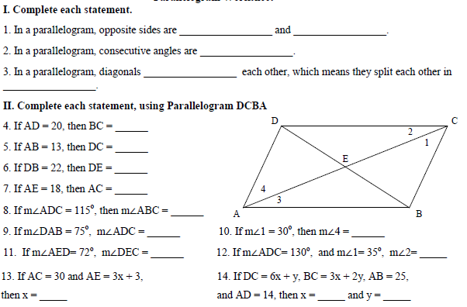 **Parallelograms Homework**

